Overview of All SEER-Medicare Publications
  - Outcomes Insights, Inc.

  - Mark D. Danese, MHS, PhD
  - Marc Halperin

  - October 11, 2020

Overview
- Information was extracted from the National Cancer Institute (NCI) online reference database for "SEER-Medicare" publications
  - http://healthcaredelivery.cancer.gov/seermedicare/overview/pubsearch.html
  - Data accessed October 11, 2020 - articles published in 2020 may be underrepresented due to reporting lag
  - 2056 citations retrieved
  - NCI classified all publications according to the following:
    - 21 tumor types (e.g., colorectal, leukemia, etc.)
- Summary measures were calculated by year, tumor site, journal, and author
- Exploratory analyses were conducted to assess publication frequency relative to cancer incidence, prevalence, and deaths
- All analyses were conducted using R version 3.2.2 (2015-08-14)
- All data were extracted from internet-based sources on October 11, 2020 using the rvest package (version 0.3.2)
- Figures were created using the ggplot2 package (version 2.2.1)
- This report was generated using the ReporteRs package (version 0.8.8)

SEER-Medicare Publications Search

Tumor Sites:
- Breast
- Prostate
- Colorectal
- Lung
- Other
- Urinary Bladder
- Pancreas
- Head and Neck
- Renal
- Lymphoma
- Ovary
- Liver
- Esophagus
- Leukemia
- Corpus Uteri
- Gastric
- Brain & Other Nervous System
- Cervical
- Multiple Myeloma
- Skin
- Testis

Summary of Publications
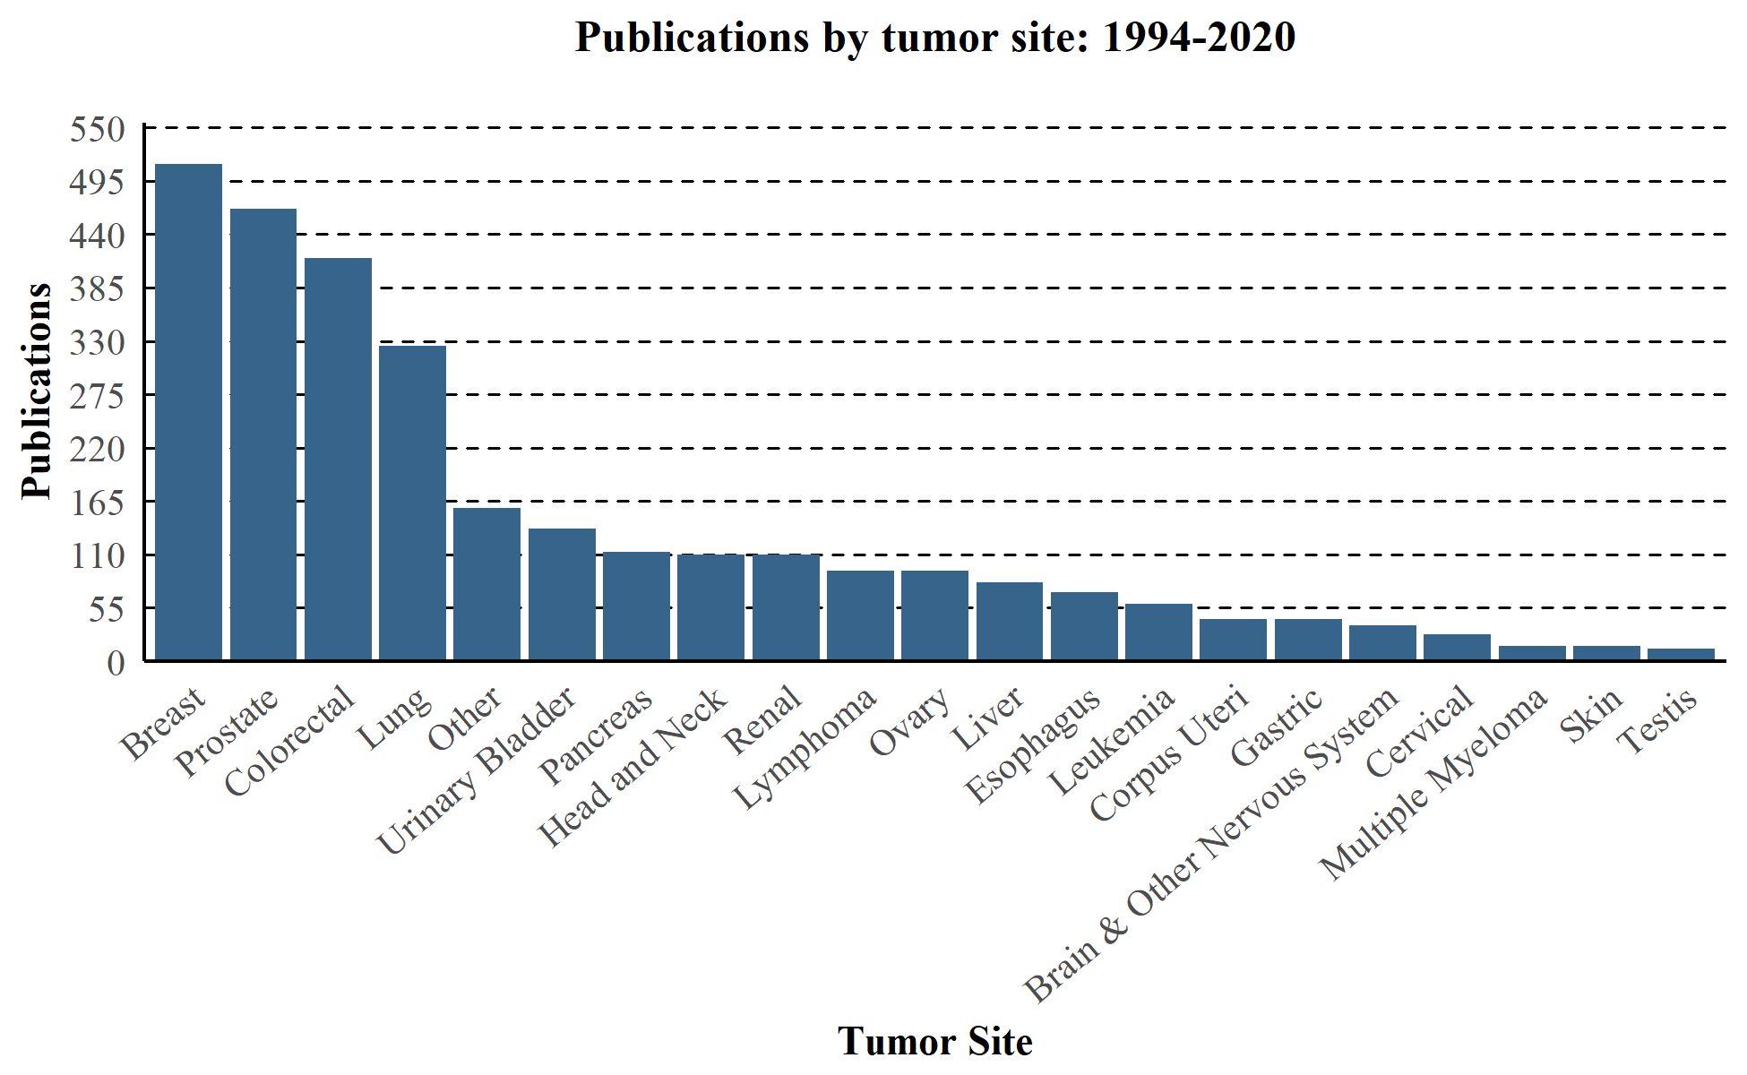

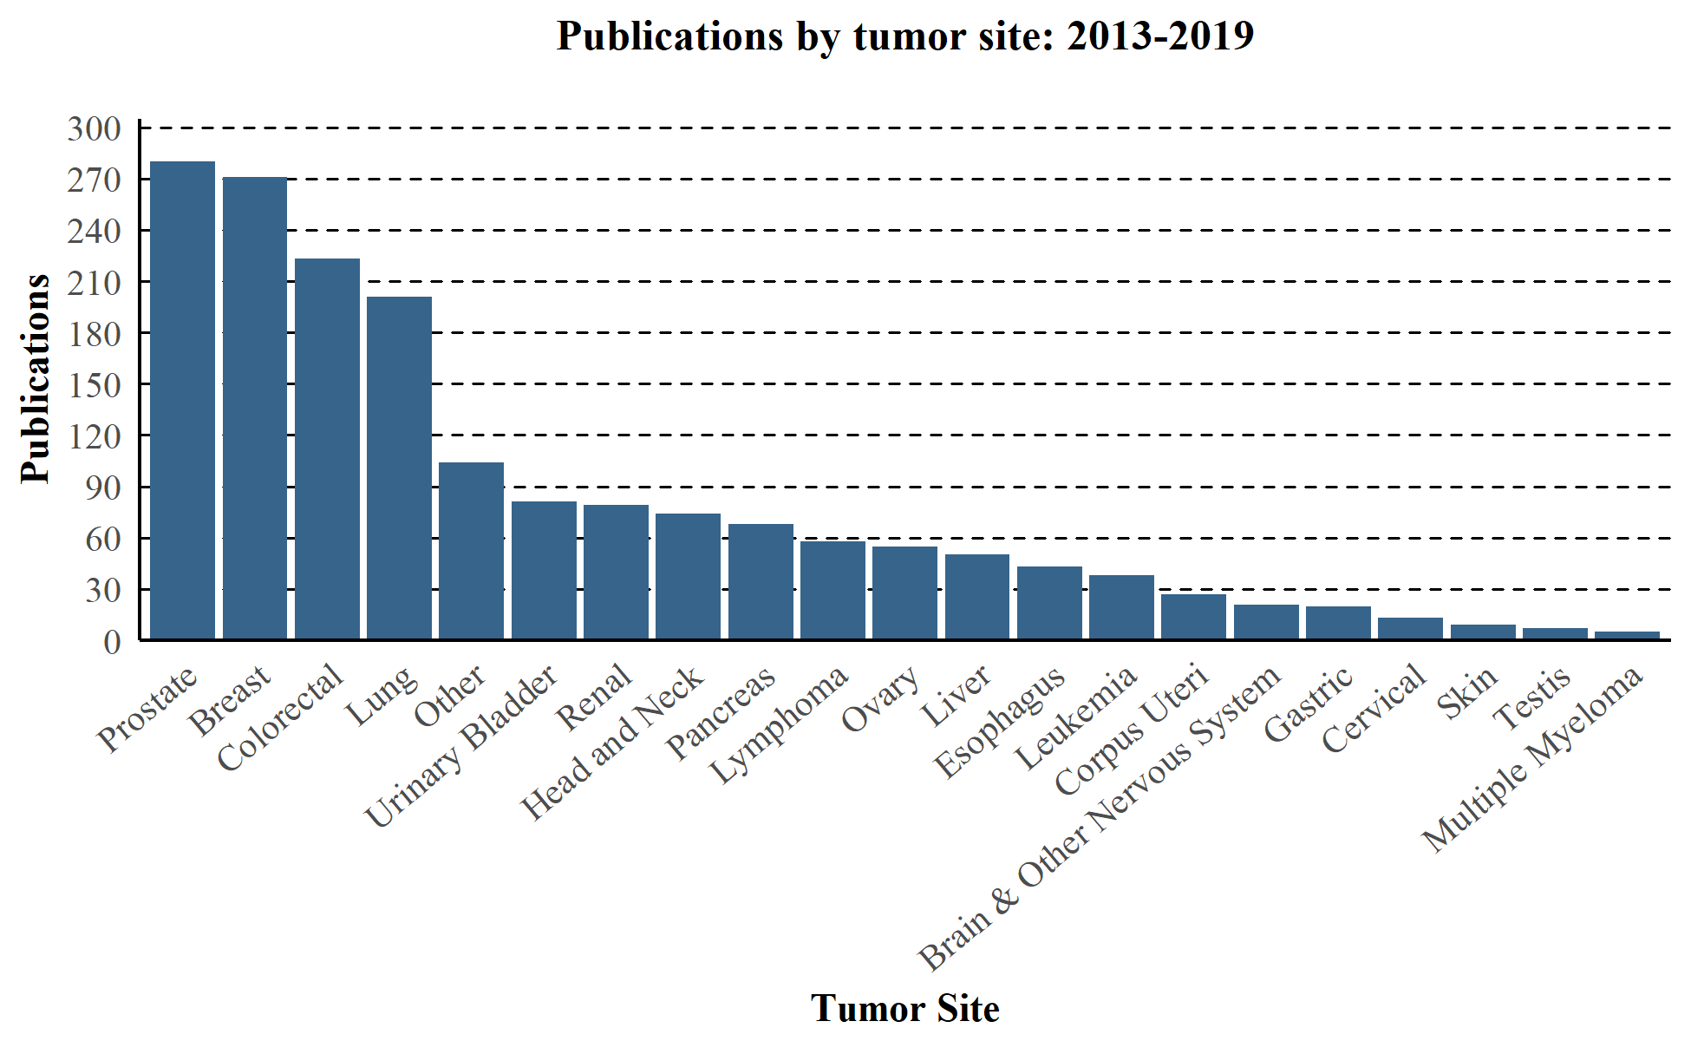
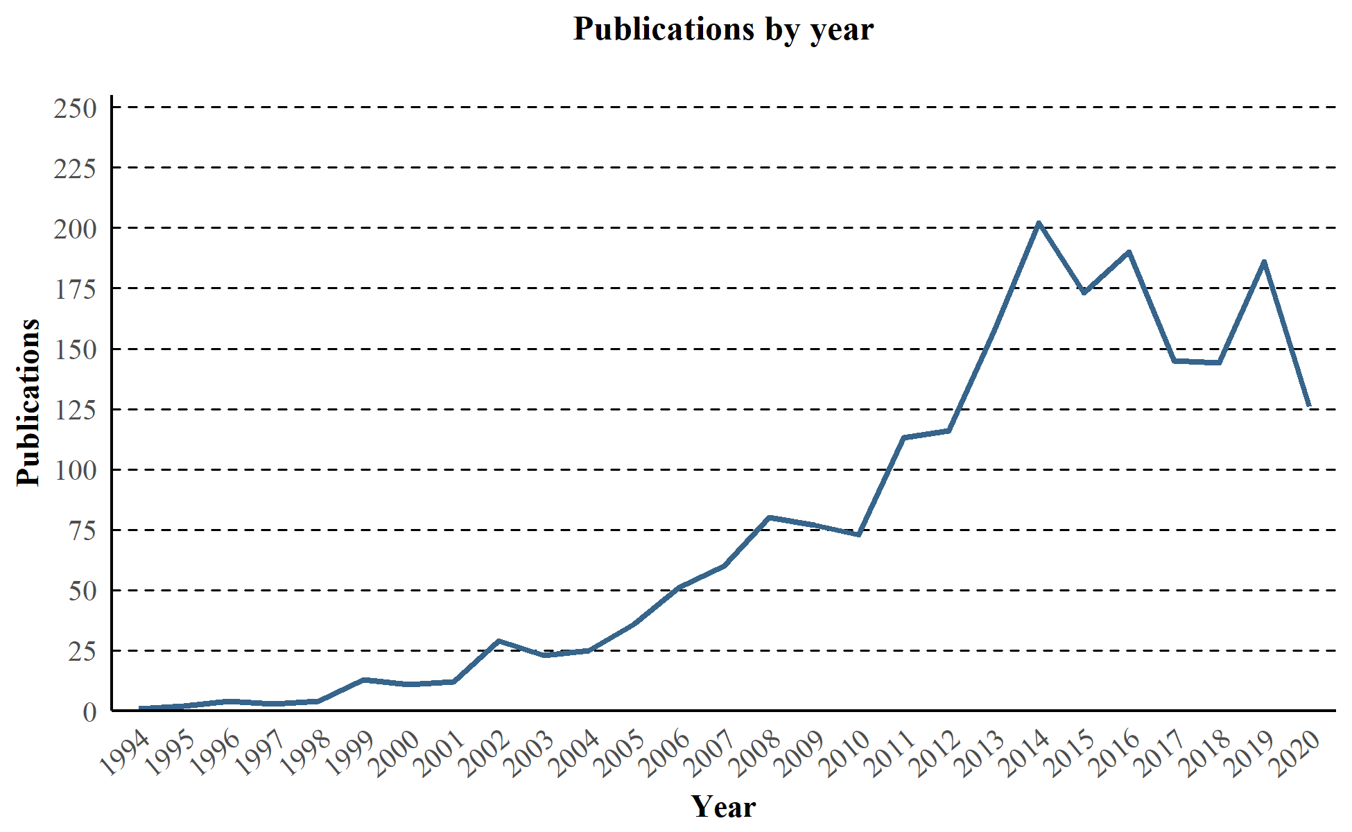

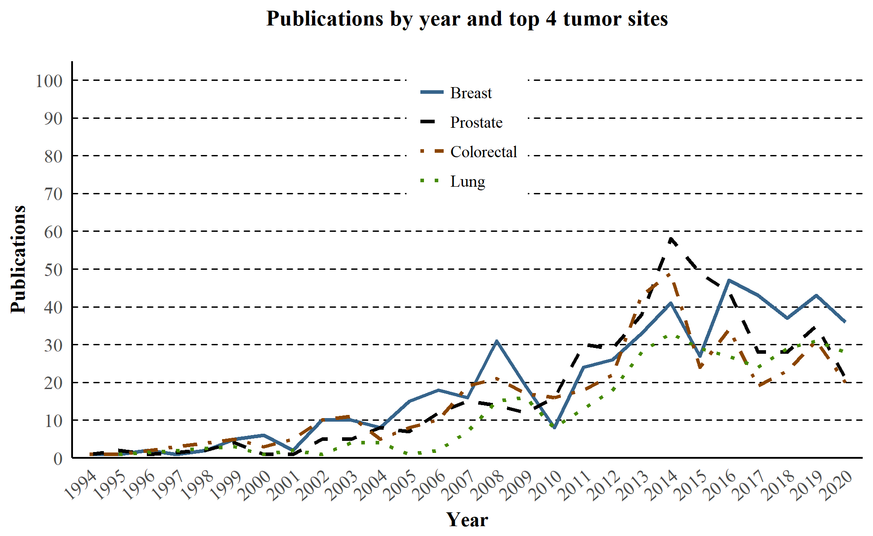
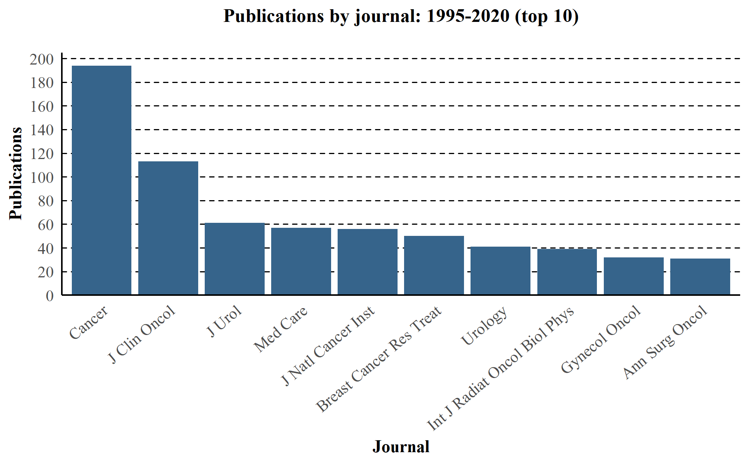

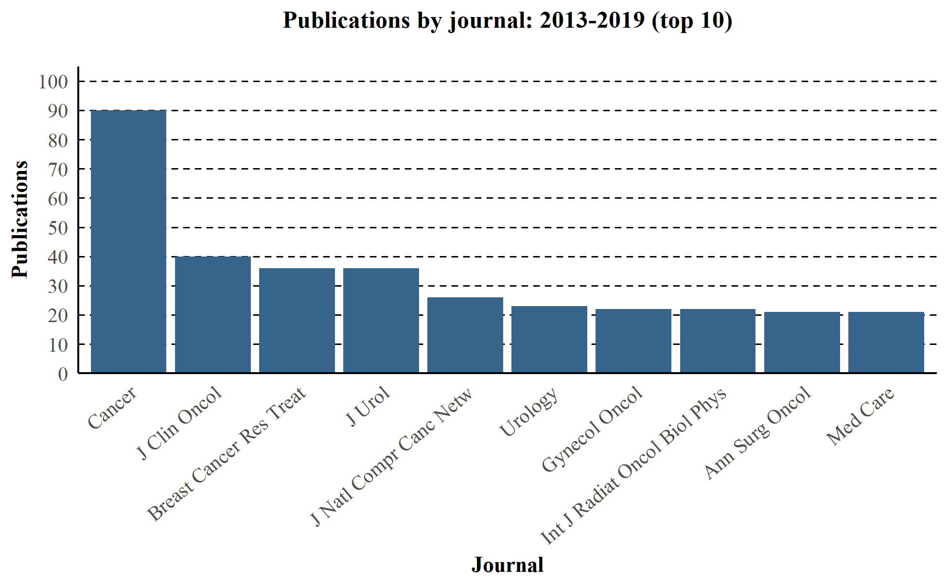
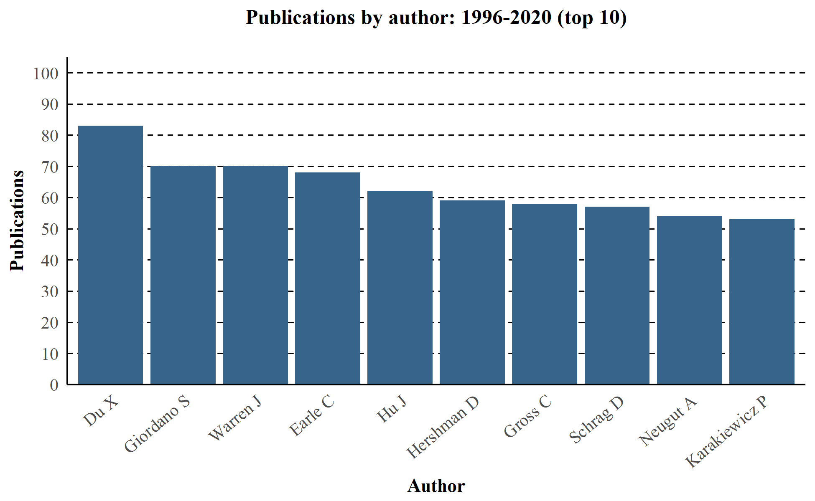

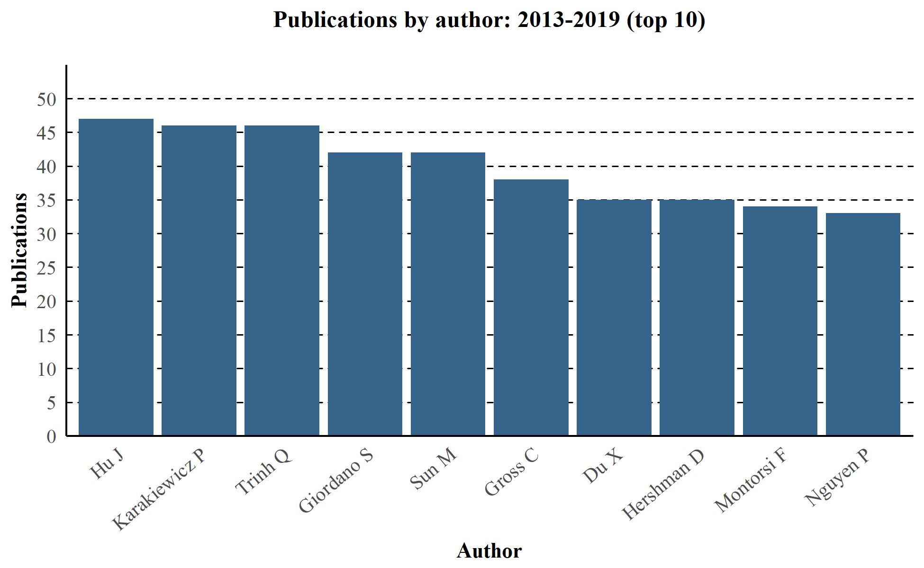

Exploratory Analyses: Publications Relative to Population Size

Methodology
- Publication counts were plotted against tumor types
- Counts of incident and prevalent patients, as well as deaths from cancer, were taken from SEER published estimates
- Ratios of publications to these patient counts were estimated
  - Publications divided by incidence (per 1,000 patients)
  - Publications divided by prevalence (per 10,000 patients)
  - Publications divided by deaths (per 1,000 patients)
  - Higher numbers reflect more publications per patient
  - The median publication ratio across all tumors was used as an index for establishing high versus low ratios
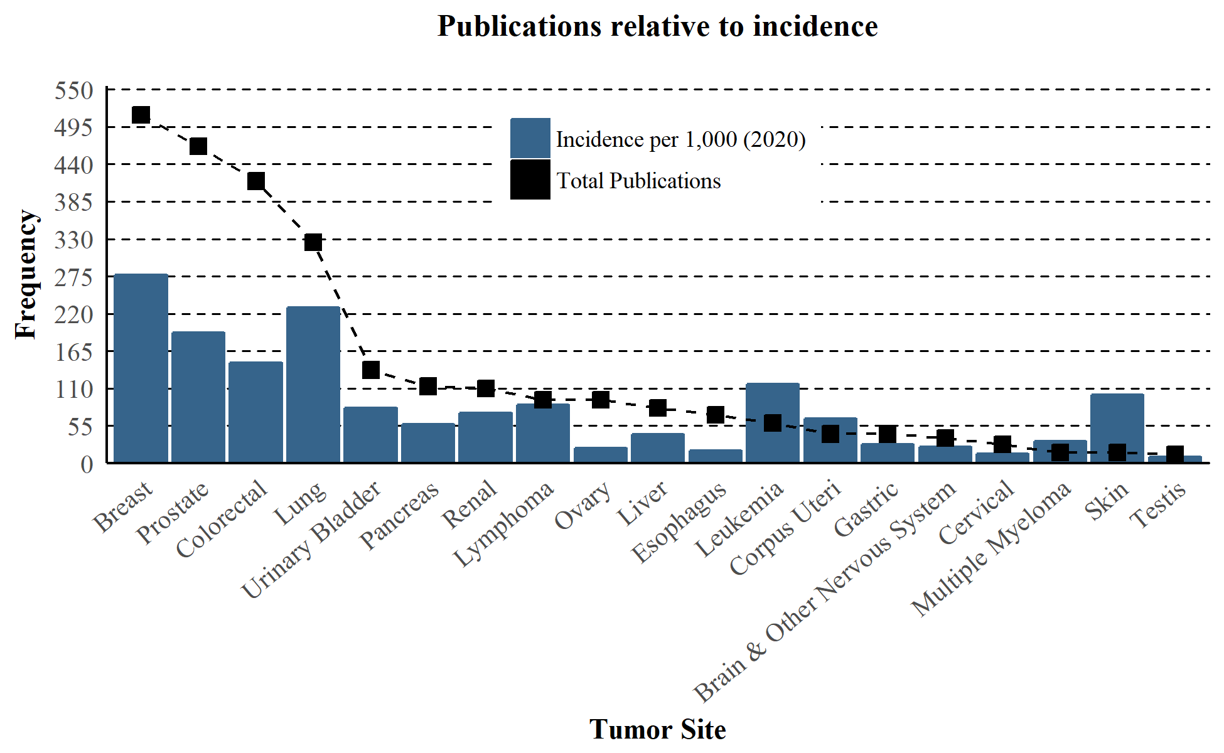
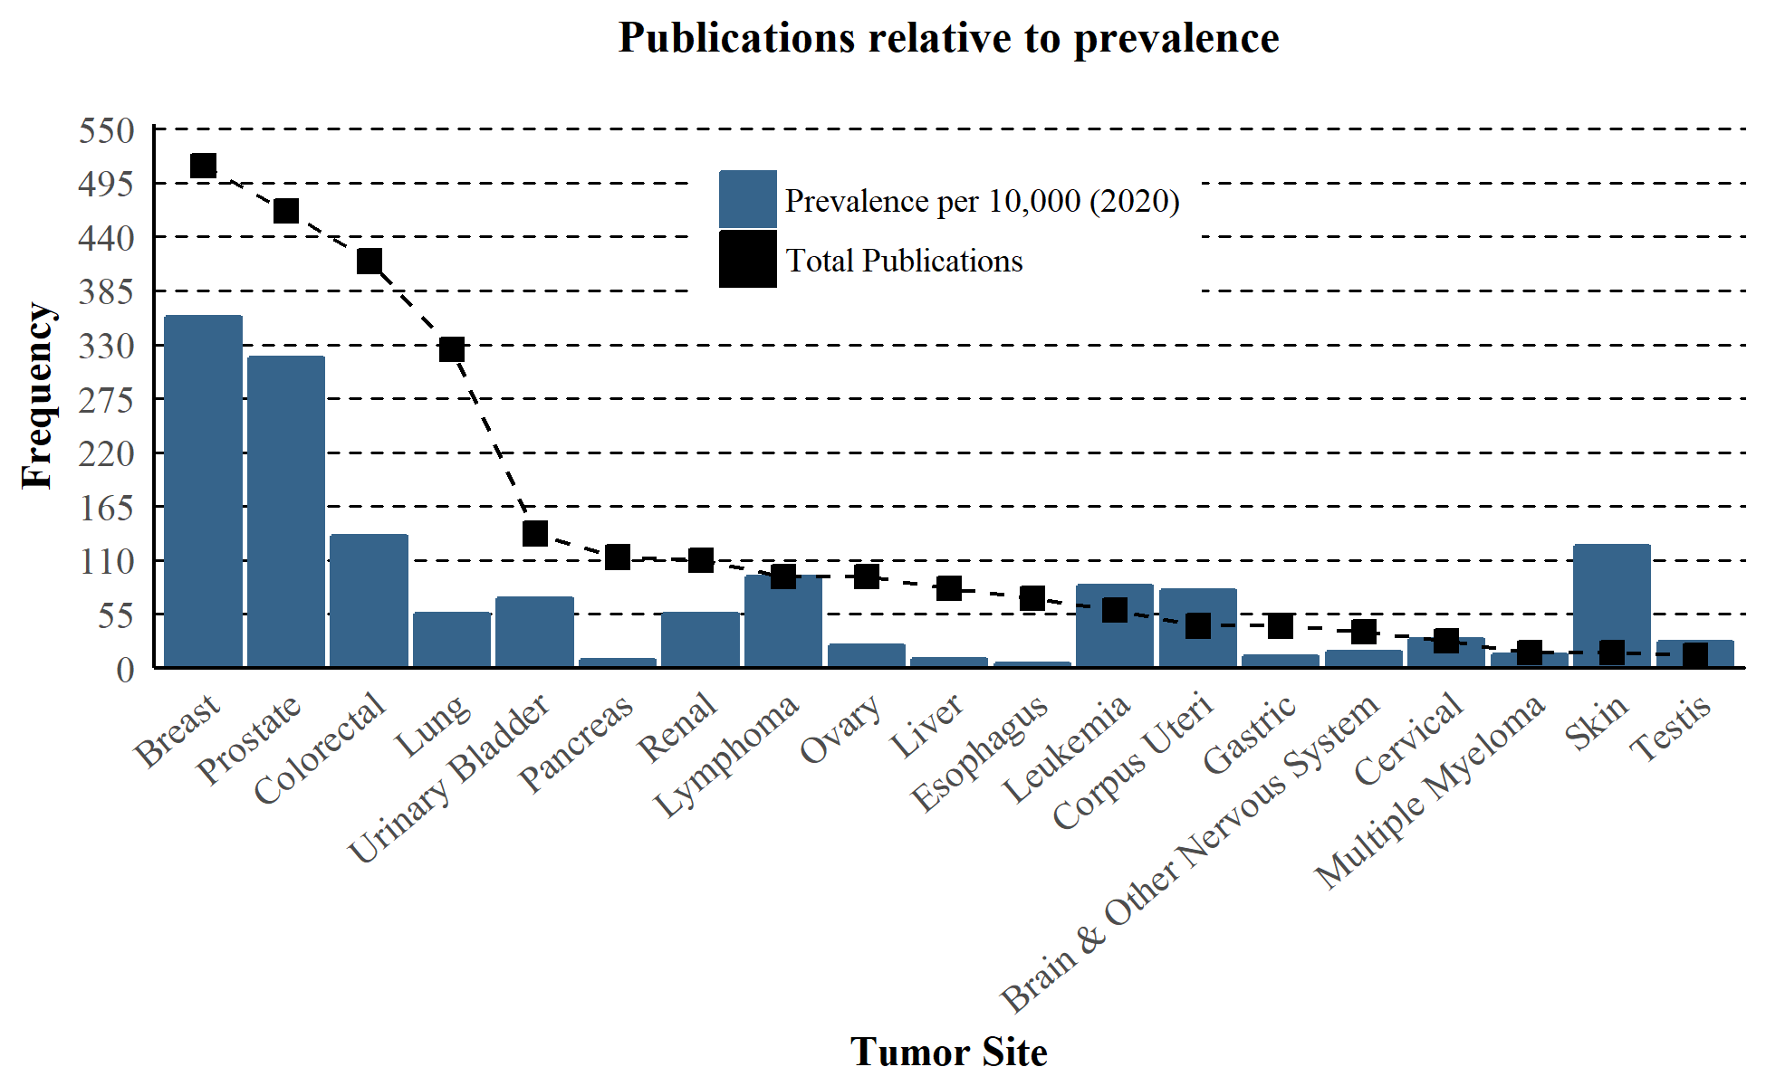
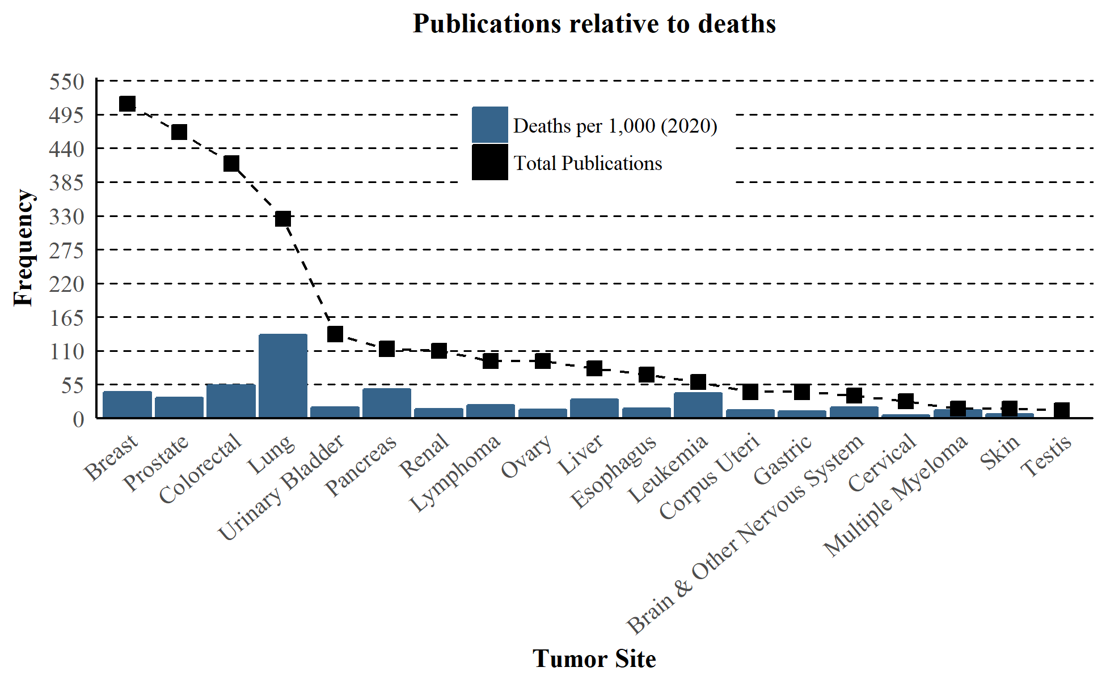

Publications per patient according to incidence, prevalence, and deaths
 | Breast | Prostate | Colorectal | Lung | Urinary Bladder | Pancreas | Renal | Lymphoma | Ovary | Liver | Esophagus | Leukemia | Corpus Uteri | Gastric | Brain & Other Nervous System | Cervical | Multiple Myeloma | Skin | Testis
Total  Publications | 512 | 466 | 415 | 325 | 137 | 113 | 110 | 93 | 93 | 81 | 71 | 59 | 43 | 43 | 37 | 28 | 16 | 16 | 13
% incident patients age 65 years  or older (2013-2017) | 44% | 60% | 57% | 70% | 74% | 67% | 50% | 54% | 48% | 51% | 61% | 57% | 45% | 61% | 39% | 20% | 64% | 51% | 3%
Pub/incidence ratio  per 1,000 (2020) | 1.9 | 2.4 | 2.8 | 1.4 | 1.7 | 2.0 | 1.5 | 1.1 | 4.3 | 1.9 | 3.9 | 0.5 | 0.7 | 1.6 | 1.5 | 2.0 | 0.5 | 0.2 | 1.4
Pub/prevalence ratio  per 10,000 (2020) | 1.4 | 1.5 | 3.1 | 5.8 | 1.9 | 14.3 | 2.0 | 1.0 | 4.0 | 9.0 | 14.9 | 0.7 | 0.5 | 3.7 | 2.2 | 1.0 | 1.1 | 0.1 | 0.5
Pub/deaths ratio  per 1,000 (2020) | 12.1 | 14.0 | 7.8 | 2.4 | 7.6 | 2.4 | 7.4 | 4.4 | 6.7 | 2.7 | 4.4 | 1.4 | 3.4 | 3.9 | 2.1 | 6.5 | 1.2 | 2.3 | 29.5
Notes: Higher numbers indicate more publications per patient (see next table for comparisons to the median ratios)

Publications per patient according to incidence, prevalence, and deaths, standardized to the median ratio
 | Breast | Prostate | Colorectal | Lung | Urinary Bladder | Pancreas | Renal | Lymphoma | Ovary | Liver | Esophagus | Leukemia | Corpus Uteri | Gastric | Brain & Other Nervous System | Cervical | Multiple Myeloma | Skin | Testis
Total  Publications | 512 | 466 | 415 | 325 | 137 | 113 | 110 | 93 | 93 | 81 | 71 | 59 | 43 | 43 | 37 | 28 | 16 | 16 | 13
% incident patients age 65 years  or older (2013-2017) | 44% | 60% | 57% | 70% | 74% | 67% | 50% | 54% | 48% | 51% | 61% | 57% | 45% | 61% | 39% | 20% | 64% | 51% | 3%
Pub/incidence ratio  per 1,000 (2020) | 1.2 | 1.6 | 1.8 | 0.9 | 1.1 | 1.3 | 1.0 | 0.7 | 2.7 | 1.2 | 2.5 | 0.3 | 0.4 | 1.0 | 1.0 | 1.3 | 0.3 | 0.1 | 0.9
Pub/prevalence ratio  per 10,000 (2020) | 0.7 | 0.8 | 1.6 | 3.0 | 1.0 | 7.4 | 1.0 | 0.5 | 2.1 | 4.7 | 7.7 | 0.4 | 0.3 | 1.9 | 1.1 | 0.5 | 0.6 | 0.1 | 0.3
Pub/deaths ratio  per 1,000 (2020) | 2.8 | 3.2 | 1.8 | 0.5 | 1.7 | 0.5 | 1.7 | 1.0 | 1.5 | 0.6 | 1.0 | 0.3 | 0.8 | 0.9 | 0.5 | 1.5 | 0.3 | 0.5 | 6.7
Notes: Ratios reflect the tumor-specific publication ratio relative to median publication ratio (see previous table for non-standardized ratios)
Values above 1.0 indicate ratios higher than the median, and values below 1.0 indicate ratios below the median (shaded orange)

Conclusions
- There has been steady growth in the number of publications over time using the SEER-Medicare data
- Breast, prostate, colorectal, and lung are the tumor sites with the highest number of publications
- The number of publications appears to align better with incidence and prevalence than with death, particularly for more common cancers
- Leukemia, corpus uteri, multiple myeloma, and skin might be under-represented in terms of the absolute number of publications

Data Sources
- Incidence (2020), Prevalence (2020), Deaths (2020)
  - Howlader N, Noone AM, Krapcho M, Miller D, Brest A, Yu M, Ruhl J, Tatalovich Z, Mariotto A, Lewis DR, Chen HS, Feuer EJ, Cronin KA (eds). SEER Cancer Statistics Review, 1975-2017, National Cancer Institute. Bethesda, MD, https://seer.cancer.gov/csr/1975_2017/, based on November 2019 SEER data submission, posted to the SEER web site, April 2020.
- Proportion of patients age 65 or older at diagnosis (2013-2017)
  - Howlader N, Noone AM, Krapcho M, Miller D, Brest A, Yu M, Ruhl J, Tatalovich Z, Mariotto A, Lewis DR, Chen HS, Feuer EJ, Cronin KA (eds). SEER Cancer Statistics Review, 1975-2017, National Cancer Institute. Bethesda, MD, https://seer.cancer.gov/csr/1975_2017/, based on November 2019 SEER data submission, posted to the SEER web site, April 2020.
- All Site and Morphology classifications were aligned among all data sources with a few exceptions:
  - Head and Neck was defined using SEER/CDC category: Oral Cavity and Pharynx
  - Corpus Uteri was defined using SEER/CDC category: Endometrial Cancer

Acknowledgements
Thanks to Ryan Duryea who helped to automate this and previous versions of this report

Contact Information
Mark D. Danese
Outcomes Insights, Inc.
30200 Agoura Road, Suite 230
Agoura Hills, CA 91302
805-498-0034
mark@outins.com
www.outins.com

